

MAD Lab 9

Submitted to :Sir Nisar Siddiqui



Muhammad daniyal qureshi

021-18-0009

BSCS_VII_A

Contents

Activity 1: Create an Expandable notification 1

Activity 2: Create an SMS reader app 8

Activity 3: Create a user dictionary and make it available so that other applications can read and update the words in the dictionary. 11

# Activity 1: Create an Expandable notification

**Layout Code**

<?xml version="1.0" encoding="utf-8"?>

<androidx.constraintlayout.widget.ConstraintLayout xmlns:android="http://schemas.android.com/apk/res/android"

    xmlns:app="http://schemas.android.com/apk/res-auto"

    xmlns:tools="http://schemas.android.com/tools"

    android:layout_width="match_parent"

    android:layout_height="match_parent"

    tools:context=".MainActivity">

    <Button

        android:id="@+id/button"

        android:layout_width="0dp"

        android:layout_height="wrap_content"

        android:layout_marginTop="104dp"

        android:onClick="shownotification"

        android:text="Messenger"

        android:textColor="#100303"

        android:textSize="20sp"

        app:backgroundTint="#C1B9BB"

        app:layout_constraintEnd_toEndOf="parent"

        app:layout_constraintHorizontal_bias="0.0"

        app:layout_constraintStart_toStartOf="parent"

        app:layout_constraintTop_toTopOf="parent" />

</androidx.constraintlayout.widget.ConstraintLayout>

<?xml version="1.0" encoding="utf-8"?>

<LinearLayout xmlns:android="http://schemas.android.com/apk/res/android"

    android:orientation="vertical" android:layout_width="match_parent"

    android:layout_height="175dp"

    >

<LinearLayout

    android:layout_width="match_parent"

    android:layout_height="wrap_content"

 >

    <ImageView

        android:layout_width="30dp"

        android:layout_height="30dp"

        android:src="@drawable/im"

        android:layout_marginLeft="10dp"

        >

    </ImageView>

<TextView

    android:layout_width="wrap_content"

    android:layout_height="wrap_content"

    android:text="   Messenger App"

    android:textSize="15sp"

    >

</TextView>

</LinearLayout>

<LinearLayout

    android:layout_width="match_parent"

    android:layout_height="wrap_content"

    android:orientation="horizontal"

    android:layout_marginTop="20dp"

    >

<TextView

    android:layout_width="wrap_content"

    android:layout_height="wrap_content"

    android:text="Friend Requests"

    android:layout_weight="2"

        android:textSize="30sp"

    android:textColor="@color/black"

    ></TextView>

<ImageView

    android:layout_width="50dp"

    android:layout_height="50dp"

    android:src="@drawable/on"

    android:layout_weight="1"

    >

    ></ImageView>

</LinearLayout>

    <TextView

        android:layout_width="wrap_content"

        android:layout_height="wrap_content"

        android:text="1 out of 3 categories from this app"

        android:textSize="20sp"

        android:textColor="@color/black"

        ></TextView>

    <LinearLayout

        android:layout_width="match_parent"

        android:layout_height="wrap_content"

        android:orientation="horizontal"

        android:layout_marginTop="20dp"

        >

        <TextView

            android:layout_width="wrap_content"

            android:layout_height="wrap_content"

            android:text="ALL CATEGORIES"

            android:textSize="20sp"

           android:layout_marginLeft="100dp"

            android:textColor="#3792cb"

            android:textStyle="bold"

            android:clickable="true"

            >

        </TextView>

     <TextView

            android:layout_width="wrap_content"

            android:layout_height="wrap_content"

            android:text="    DONE"

            android:textStyle="bold"

            android:textSize="20sp"

            android:clickable="true"

            android:textColor="#3792cb"

            >

        </TextView>

    </LinearLayout>

</LinearLayout>

**Logic Code**

package com.example.uinotification;

import androidx.annotation.RequiresApi;

import androidx.appcompat.app.AppCompatActivity;

import androidx.core.app.NotificationCompat;

import androidx.core.app.NotificationManagerCompat;

import android.annotation.SuppressLint;

import android.app.Notification;

import android.app.NotificationChannel;

import android.app.NotificationManager;

import android.app.PendingIntent;

import android.app.StatusBarManager;

import android.content.Intent;

import android.os.Build;

import android.os.Bundle;

import android.service.notification.StatusBarNotification;

import android.util.Log;

import android.view.View;

import android.widget.RemoteViews;

public class MainActivity extends AppCompatActivity {

    private static final Object EXTRA_NOTIFICATION_ID =12 ;

    NotificationManagerCompat notificationManager;

    @Override

    protected void onCreate(Bundle savedInstanceState) {

        super.onCreate(savedInstanceState);

        setContentView(R.layout.activity_main);

     notificationManager= NotificationManagerCompat.from(this);

    }

        @RequiresApi(api = Build.VERSION_CODES.N)

        public void shownotification(View view) throws InterruptedException {

        Notification.Builder builder1=new Notification.Builder(this)

                .setSmallIcon(R.drawable.comment)

                .setContentTitle("Instant Message")

                .setContentText("Hey, what are you doing for lunch?")

                .setAutoCancel(true);

        NotificationManager manager=(NotificationManager)getSystemService(NOTIFICATION_SERVICE);

        if(Build.VERSION.SDK_INT>=Build.VERSION_CODES.O)

        {

            @SuppressLint("WrongConstant") NotificationChannel channel=new NotificationChannel("example","Android",NotificationManager.IMPORTANCE_DEFAULT);

                manager.createNotificationChannel(channel);

            builder1.setChannelId("example");

        }

            RemoteViews collapsed=new RemoteViews(getPackageName(),R.layout.notification_custom);

             Notification.Builder builder=new Notification.Builder(this)

                    .setSmallIcon(R.drawable.comment)

                    .setContentTitle("Instant Message")

                    .setCustomBigContentView(collapsed)

                    .setAutoCancel(true);

         manager.notify(123,builder1.build());

            manager.notify(1234,builder.build());

    }

}

**Output**

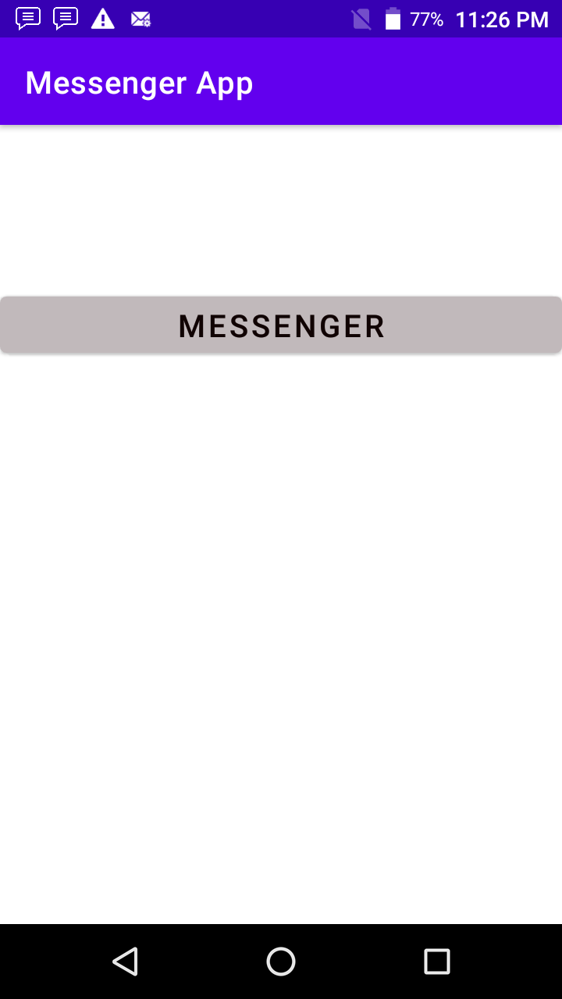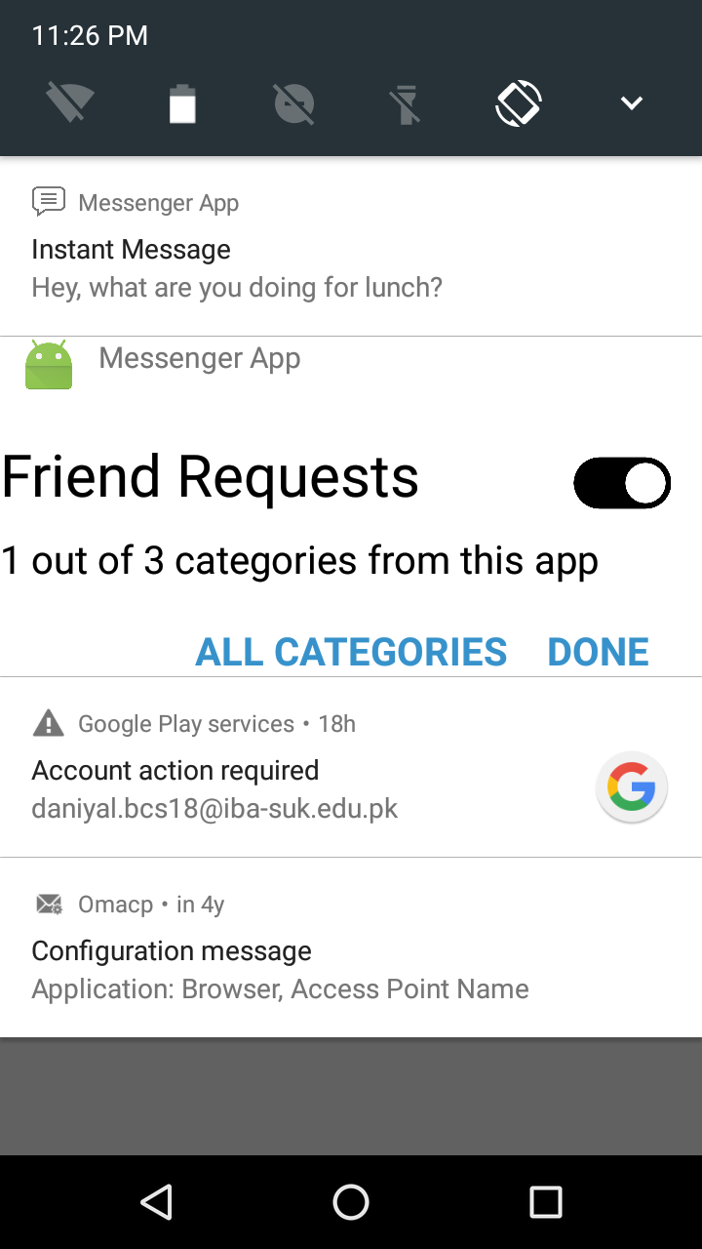

# Activity 2: Create an SMS reader app

**Layout Code**

<?xml version="1.0" encoding="utf-8"?>

<LinearLayout xmlns:android="http://schemas.android.com/apk/res/android"

    xmlns:app="http://schemas.android.com/apk/res-auto"

    xmlns:tools="http://schemas.android.com/tools"

    android:layout_width="match_parent"

    android:layout_height="match_parent"

    tools:context=".MainActivity"

    android:orientation="horizontal"

    >

    <ListView

        android:layout_width="match_parent"

        android:layout_height="match_parent"

        android:id="@+id/list"

        >

    </ListView>

</LinearLayout>

**Logic Code**

  package com.example.message;

import androidx.appcompat.app.AppCompatActivity;

import androidx.core.app.ActivityCompat;

import androidx.core.content.ContextCompat;

import android.Manifest;

import android.content.pm.PackageManager;

import android.database.Cursor;

import android.net.Uri;

import android.os.Bundle;

import android.provider.ContactsContract;

import android.telephony.SmsManager;

import android.widget.ListView;

import android.widget.SimpleAdapter;

import android.widget.Toast;

import java.util.ArrayList;

import java.util.HashMap;

import java.util.List;

import java.util.Map;

  public class MainActivity extends AppCompatActivity {

    @Override

    protected void onCreate(Bundle savedInstanceState) {

        super.onCreate(savedInstanceState);

        setContentView(R.layout.activity_main);

        List<Map<String,String>> data=new ArrayList<Map<String, String>>();

        SimpleAdapter adapter=new SimpleAdapter(this,data, android.R.layout.simple_expandable_list_item_2,

                new String[]{"title","subtitle"},new int[]{android.R.id.text1,android.R.id.text2}

                );

        ListView listView=findViewById(R.id.list);

        if(ActivityCompat.checkSelfPermission(this, Manifest.permission.READ_SMS) == PackageManager.PERMISSION_GRANTED){

            Cursor c=getContentResolver().query(Uri.parse("content://sms/inbox"),null,null,null,null);

            c.moveToFirst();

            while(c.moveToNext()){

                Map<String,String> d=new HashMap<String, String>(2);

                d.put("title",c.getString(c.getColumnIndex("address")));

                d.put("subtitle",c.getString(c.getColumnIndex("body")));

                data.add(d);

            }

            listView.setAdapter(adapter);

        }

        else{

            ActivityCompat.requestPermissions(this,new String[]{Manifest.permission.READ_SMS},123);

        }

    }

}

**Output**

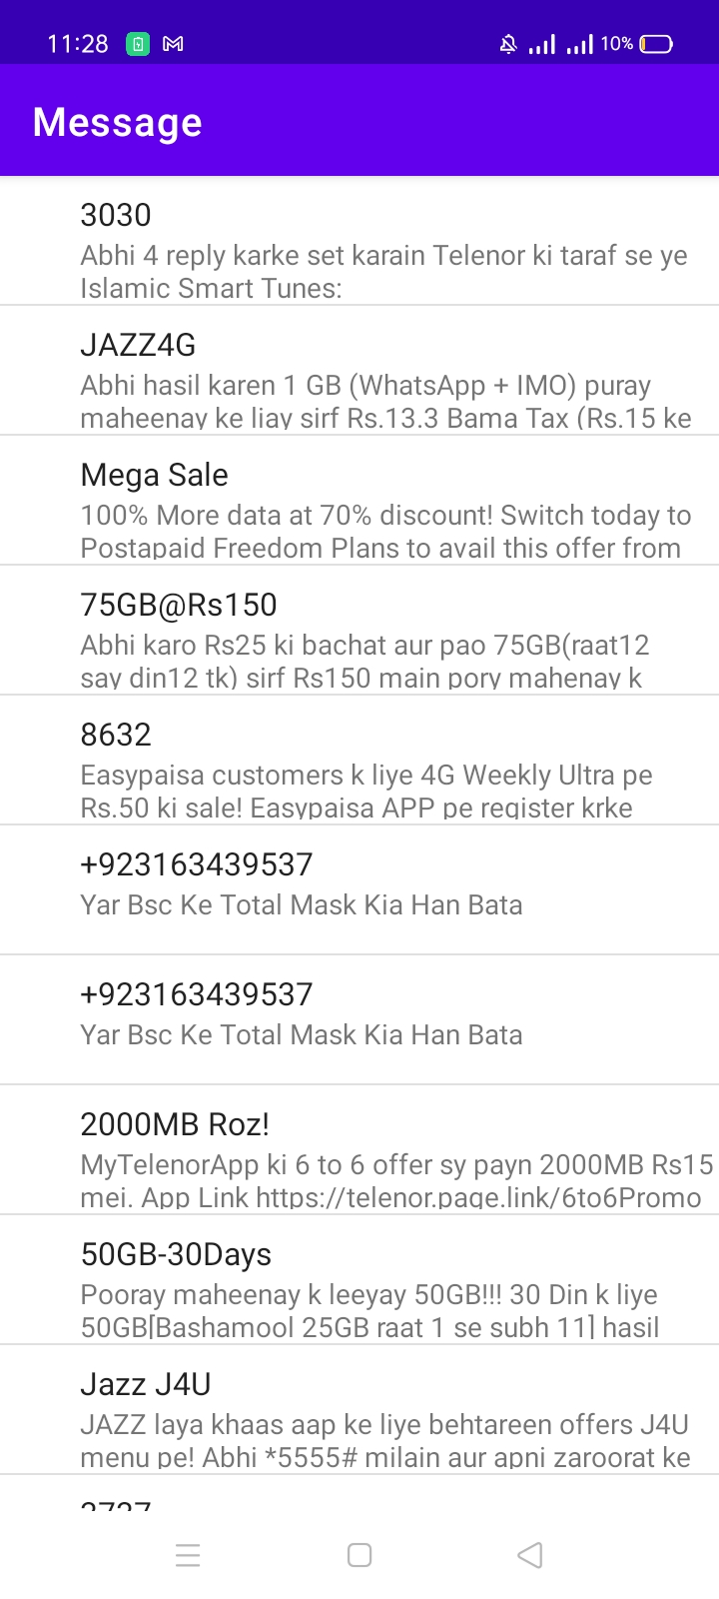

# Activity 3: Create a user dictionary and make it available so that other applications can read and update the words in the dictionary.

**Layout Code**

<?xml version="1.0" encoding="utf-8"?>

<LinearLayout xmlns:android="http://schemas.android.com/apk/res/android"

    xmlns:app="http://schemas.android.com/apk/res-auto"

    xmlns:tools="http://schemas.android.com/tools"

    android:layout_width="match_parent"

    android:layout_height="match_parent"

    tools:context=".MainActivity">

    <ListView

        android:layout_width="match_parent"

        android:layout_height="match_parent"

        android:id="@+id/listview"

         />

</LinearLayout>

**Menu**

<?xml version="1.0" encoding="utf-8"?>

<menu xmlns:android="http://schemas.android.com/apk/res/android"

    xmlns:app="http://schemas.android.com/apk/res-auto">

<item

        android:id="@+id/search"

    app:showAsAction="always"

    android:title="search"

    android:icon="@android:drawable/ic_menu_search"

    />

    <item

        android:id="@+id/add"

        app:showAsAction="never"

        android:title="add"

        />

</menu>

**Logic Code**

package com.example.dictionary;

import androidx.annotation.NonNull;

import androidx.appcompat.app.AlertDialog;

import androidx.appcompat.app.AppCompatActivity;

import android.content.ContentValues;

import android.content.DialogInterface;

import android.database.Cursor;

import android.graphics.Color;

import android.net.Uri;

import android.os.Bundle;

import android.util.Log;

import android.view.Menu;

import android.view.MenuInflater;

import android.view.MenuItem;

import android.view.View;

import android.widget.ArrayAdapter;

import android.widget.EditText;

import android.widget.ListView;

import android.widget.Toast;

import java.util.ArrayList;

import java.util.List;

public class MainActivity extends AppCompatActivity {

    ListView view;

    ArrayAdapter<String> arrayAdapter;

    List<String> list;

    @Override

    protected void onCreate(Bundle savedInstanceState) {

        super.onCreate(savedInstanceState);

        setContentView(R.layout.activity_main);

        // Retrieve student records

        String URL = "content://com.example.dictionary/login/" ;

        Uri dictionaryURI = Uri.parse ( URL );

        Cursor c = getContentResolver().query( dictionaryURI, null , null , null , null );

        list=new ArrayList<String >();

        c.moveToFirst();

            do {

                       list.add(0,c.getString (c.getColumnIndex ("name")));

            } while ( c.moveToNext ());

        arrayAdapter=new ArrayAdapter<String>(this, android.R.layout.simple_list_item_1,list);

        view=findViewById(R.id.listview);

        view.setAdapter(arrayAdapter);

    }

    @Override

    public boolean onOptionsItemSelected(@NonNull MenuItem item) {

            switch (item.getItemId()){

                case R.id.search:

                    getData("Enter a word to search");

                    break;

                case R.id.add:

                    getData("Insert word to dictionary");

                    break;

            }

        return super.onOptionsItemSelected(item);

    }

    public void getData(String title){

        AlertDialog.Builder alert=new AlertDialog.Builder(this);

        alert.setTitle(title);

        EditText input=new EditText(this);

        alert.setView(input);

        alert.setPositiveButton("Ok", new DialogInterface.OnClickListener() {

            @Override

            public void onClick(DialogInterface dialog, int which) {

                if(title.equals("Enter a word to search")){

                    searchword(input.getText().toString());

                }

                else

                    addword(input.getText().toString());

            }

        });

        alert.show();

    }

    @Override

    public boolean onCreateOptionsMenu(Menu menu) {

        MenuInflater inflater=getMenuInflater();

        inflater.inflate(R.menu.menu,menu);

        return true;

    }

    public void addword(String word){

        ContentValues values = new ContentValues();

        values.put ("name", word);

        Uri uri = getContentResolver (). insert (dict.CONTENT_URI , values );

        list.add(0,word);

        arrayAdapter=new ArrayAdapter<String>(this, android.R.layout.simple_list_item_1,list);

        view.setAdapter(arrayAdapter);

    }

    public void searchword(String word){

        String URL = "content://com.example.dictionary/login/" ;

        Uri dictionaryURI = Uri.parse ( URL );

        Cursor c = getContentResolver().query( dictionaryURI, null , "name=?" , new String[]{word} , null );

        if(c.getCount()==0)

            return;

        c.moveToFirst();

        List<String> list2=new ArrayList<String>();

        do {

            list2.add(c.getString (c.getColumnIndex ("name")));

        } while ( c.moveToNext ());

        arrayAdapter=new ArrayAdapter<String>(this, android.R.layout.simple_list_item_1,list2);

        view.setAdapter(arrayAdapter);

    }

}

**Content Provider**

package com.example.dictionary;

import android.content.ContentProvider;

import android.content.ContentUris;

import android.content.ContentValues;

import android.content.Context;

import android.content.UriMatcher;

import android.database.Cursor;

import android.database.sqlite.SQLiteDatabase;

import android.net.Uri;

import android.util.Log;

public class dict extends ContentProvider {

    static final String PROVIDER_NAME = "com.example.dictionary" ;

    static final String URL = "content://" + PROVIDER_NAME + "/login/" ;

    static final Uri CONTENT_URI = Uri.parse (URL);

    DBHelper helper;

    SQLiteDatabase db;

    @Override

    public int delete(Uri uri, String selection, String[] selectionArgs) {

        // Implement this to handle requests to delete one or more rows.

        throw new UnsupportedOperationException("Not yet implemented");

    }

    @Override

    public String getType(Uri uri) {

        // TODO: Implement this to handle requests for the MIME type of the data

        // at the gi ven URI.

        throw new UnsupportedOperationException("Not yet implemented");

    }

    @Override

    public Uri insert(Uri uri, ContentValues values) {

        long rowID = db.insert("login", "", values);

        if (rowID > 0) {

            Uri _uri = ContentUris.withAppendedId(CONTENT_URI, rowID);

            getContext().getContentResolver().notifyChange(_uri, null);

            return _uri;

        }

        return null;

    }

    @Override

    public boolean onCreate() {

            helper=new DBHelper(getContext());

            db=helper.getWritableDatabase();

            return (db==null) ?false: true;

    }

    @Override

    public Cursor query(Uri uri, String[] projection, String selection,

                        String[] selectionArgs, String sortOrder) {

        db=helper.getReadableDatabase();

        Cursor c=db.query("login",projection,selection,selectionArgs,null,null,null);

        return c;

    }

    @Override

    public int update(Uri uri, ContentValues values, String selection,

                      String[] selectionArgs) {

        // TODO: Implement this to handle requests to update one or more rows.

        throw new UnsupportedOperationException("Not yet implemented");

    }

}

**SQLite Open Helper**

package com.example.dictionary;

import android.content.Context;

import android.database.Cursor;

import android.database.sqlite.SQLiteDatabase;

import android.database.sqlite.SQLiteOpenHelper;

import android.util.Log;

import androidx.annotation.Nullable;

public class DBHelper extends SQLiteOpenHelper {

    public DBHelper(@Nullable Context context) {

        super(context, "dictionary", null, 1);

    }

    @Override

    public void onCreate(SQLiteDatabase db) {

        db.execSQL("CREATE TABLE login(name TEXT NOT NULL);");

    }

    @Override

    public void onUpgrade(SQLiteDatabase db, int oldVersion, int newVersion) {

        db.execSQL ( "DROP TABLE IF EXISTS login");

        onCreate(db);

    }

}

**Output**

